Database Management Systems

Bookstore

Final Report

Olenger Bloxson

Vernon Cole

**Project Summary**

The objective of this project was to build and maintain a bookstore database with an attached front end. The project was broken into three milestones, the ER diagram, the relational schema, and the final product, more detail about each provided milestone are below.

**ER Diagram**

The ER diagram is used to describe the entities, relationships, and attributes at a more conceptual level.

**Relational Schema**

The relational schema serves the purpose of visualizing the relationships and their attributes, before converting them into a functional database.

**Final Product**

After constructing the ER Diagram and the Relational Schema, the next step is to construct the database itself. Once that part is we want to create a front-end interface that allows a customer to create and update their account, search and browse for books, add items to order then modify if needed, and view their order.

The front end should also include admin access where a manager or someone with sufficient privileges will be able to view customers, orders, books, suppliers, and the authors of books. As well as update details for customers, authors, and books in the database. They can also remove a customer, author, book, or supplier from the database if needed.

**ER Diagram**

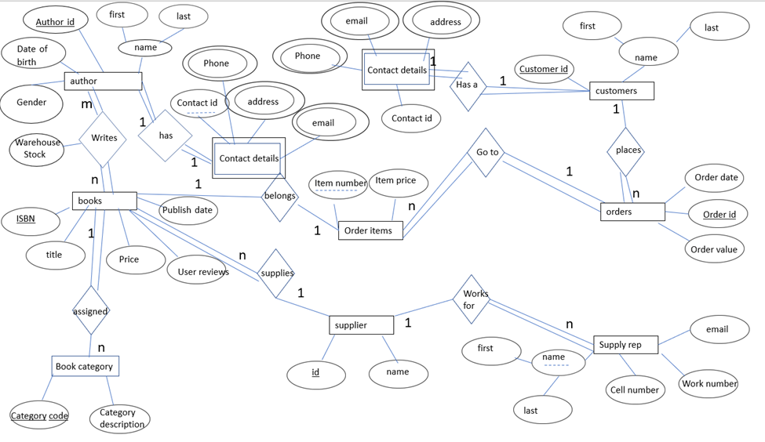

**Relational Schema**

author(author_id, birthdate, gender, first, last)

Primary key = author_id

books(ISBN, title, price, reviews, publish_date, supplier_id)

Primary key = ISBN

Foreign key = supplier_id

warehouse(authur_id, ISBN, stock)

Primary key = {author_id, ISBN}

Foreign key = {author_id, ISBN}

bookCategory(category_code, category_description, ISBN)

Primary key = category_code

Foreign key = ISBN

supplier(supplier id, name)

Primary key = supplier_id

supply_rep(first, last, cell_number, work_number, email, supplier_id)

Primary key = {first, last, supplier_id}

Foreign key = supplier_id

orders(order_id, order_date, order_value, customer_id

Primary key = order_id

Foreign key = customer_id

customers(customer_id, first, last)

Primary key = customer_id

Foreign key = contact_id

customer_contact_details(contact_id, customer_id)

Primary key = {contact_id, coustomer_id}

Foreign key = customer_id

customer_number(phone, contact_id, customer_id)

Primary key = {contact_id, coustomer_id}

Foreign key = {contact_id, coustomer_id}

customer_email(email, contact_id, customer_id)

Primary key = {contact_id, coustomer_id}

Foreign key = {contact_id, coustomer_id}

customer_address(address, contact_id, customer_id)

Primary key = {contact_id, coustomer_id}

Foreign key = {contact_id, coustomer_id}

author_contact_details(contact_id, author_id)

Primary key = {contact_id, author_id}

Foreign key = author_id

author_number(phone, contact_id, author_id)

Primary key = {contact_id, author_id}

Foreign key = {contact_id, author_id}

author_address(address, contact_id, author_id)

Primary key = {contact_id, author_id}

Foreign key = {contact_id, author_id}

author_email(email, contact_id, author_id)

Primary key = {contact_id, author_id}

Foreign key = {contact_id, author_id}

order_items(item_numbers, item_price, order_id, ISBN)

Primary key = {order_id, item_number}

Foreign key = {order_id, ISBN}

admin(fname, password)

Primary key {fname, password}

**Project Details**

When constructing the database we used mySQL to write and test out the creation of our tables, as well as to craft our insert commands to add some data to the database.

When it came time to work on the front end we used wampserver to provide ourselves with a server to work on and test out the front end as we worked on it. The front end for the database if primarily PHP with some HTML and CSS.

Following are the SQL queries used to construct the database:

CREATE DATABASE bookstore;

USE bookstore;

CREATE table author(author_id integer PRIMARY KEY NOT NULL, birthdate date, gender varchar(10), firstn varchar(10), lastn varchar(10));

CREATE TABLE supplier(supplier_id integer PRIMARY KEY NOT NULL, sname varchar(20));

CREATE TABLE books(

ISBN integer PRIMARY KEY NOT NULL,

title varchar(50),

price decimal(10,2),

reviews varchar(100),

publish_date date,

supplier_id integer,

foreign key (supplier_id) references supplier(supplier_id) on update CASCADE on delete CASCADE);

CREATE TABLE bookCategory(

category_code INTEGER PRIMARY KEY NOT NULL,

category_description varchar(100),

ISBN integer,

foreign key (ISBN) references books(ISBN)on update CASCADE on delete CASCADE);

create table warehouse(

author_id integer,

ISBN integer,

stock integer,

PRIMARY KEY (author_id, ISBN),

foreign key (author_id) references author(author_id) on update CASCADE on delete CASCADE,

foreign key (ISBN) references books(ISBN) on update CASCADE on delete CASCADE

);

create table supply_rep(

fname varchar(20),

lname varchar(20),

cell_number varchar(15),

work_number varchar(15),

email varchar(60),

supplier_id integer,

primary key (fname, lname),

foreign key (supplier_id) references supplier(supplier_id) on update CASCADE on delete CASCADE

);

create table customers(

customer_id integer not null,

fname varchar(20),

lname varchar(20),

contact_id integer unique,

primary key (customer_id)

);

create table customer_contact_details(

contact_id integer not null,

customer_id integer not null,

primary key (contact_id, customer_id),

foreign key (customer_id) references customers(customer_id) on update CASCADE on delete CASCADE

);

create table orders(

order_id integer not null,

order_date date,

order_value decimal(10,2),

customer_id integer not null,

primary key (order_id),

foreign key (customer_id) references customers(customer_id) on update CASCADE on delete CASCADE

);

create table customer_number(

phone varchar(15),

contact_id integer,

customer_id integer,

primary key (contact_id, customer_id),

foreign key (contact_id) references customers(contact_id) on update CASCADE on delete CASCADE,

foreign key (customer_id) references customers(customer_id) on update CASCADE on delete CASCADE

);

create table customer_email(

email varchar(50) not null,

contact_id integer,

customer_id integer,

primary key (contact_id, customer_id),

foreign key (contact_id) references customers(contact_id) on update CASCADE on delete CASCADE,

foreign key (customer_id) references customers(customer_id) on update CASCADE on delete CASCADE

);

create table customer_address(

address varchar(30) not null,

contact_id integer,

customer_id integer,

primary key (contact_id, customer_id),

foreign key (contact_id) references customers(contact_id) on update CASCADE on delete CASCADE,

foreign key (customer_id) references customers(customer_id) on update CASCADE on delete CASCADE

);

create table author_contact_details(

contact_id integer not null unique,

author_id integer not null unique,

primary key (contact_id, author_id),

foreign key (author_id) references author(author_id) on update CASCADE on delete CASCADE

);

create table author_number(

phone varchar(15) not null,

contact_id integer,

author_id integer,

primary key (contact_id, author_id),

foreign key (contact_id) references author_contact_details(contact_id) on update CASCADE on delete CASCADE,

foreign key (author_id) references author(author_id) on update CASCADE on delete CASCADE

);

create table author_address(

address varchar(50),

contact_id integer,

author_id integer,

primary key (contact_id, author_id),

foreign key (contact_id) references author_contact_details(contact_id) on update CASCADE on delete CASCADE,

foreign key (author_id) references author(author_id) on update CASCADE on delete CASCADE

);

create table author_email(

email varchar(50) not null,

contact_id integer,

author_id integer,

primary key (contact_id, author_id),

foreign key (contact_id) references author_contact_details(contact_id) on update CASCADE on delete CASCADE,

foreign key (author_id) references author(author_id) on update CASCADE on delete CASCADE

);

create table order_items(

item_numbers integer not null,

item_price decimal(10,2),

order_id integer,

ISBN integer,

primary key (item_numbers, order_id),

foreign key (order_id) references orders(order_id) on update CASCADE on delete CASCADE,

foreign key (ISBN) references books(ISBN) on update CASCADE on delete CASCADE

);

**Project Evaluation**

**What was accomplished?**

As a whole, we were able to accomplish designing the ER diagram and convert the ER diagram into a relational schema. After the relational schema, was to work on the front end to allow customers to browse and search our database. We also gave a manager or admin the ability to go in and view all the books, orders, and customers. They can also modify the categories by adding books, removing books, or orders. They can also add or update an author or supplier's information.

**What could be added or changed?**

One useful thing that could be helpful is away when creating customers, authors, or suppliers is that we can have the next available id auto inserted into the field while maintaining the unique constraint that in place for the primary keys of a database.

This could also be implemented when an admin is managing things, if we could auto-populate the fields the admin wouldn’t have to remember each ID when they want to update something.

An improved way to browse the book listing for customers, we didn’t quite get to add the ability to filter the database to narrow results to exactly what a customer might be looking for.

**Strengths/Weaknesses**

We think a strength for us was that we were able to lay a strong framework, the database, to build off of. As well as a properly connected front-end that does allow changes and updates to the database.

A weakness though was that neither of us had much front-end experience and so we spent a bunch of time focused on adding functionality to the front end and getting to connect to the database. This kind of resulted in a front in that while functional isn’t completely user-friendly. In an updated version we would want to improve the user-friendliness of the interface for both the customer and the admins. As well as make sure all functionality is fully incorporated.